1.

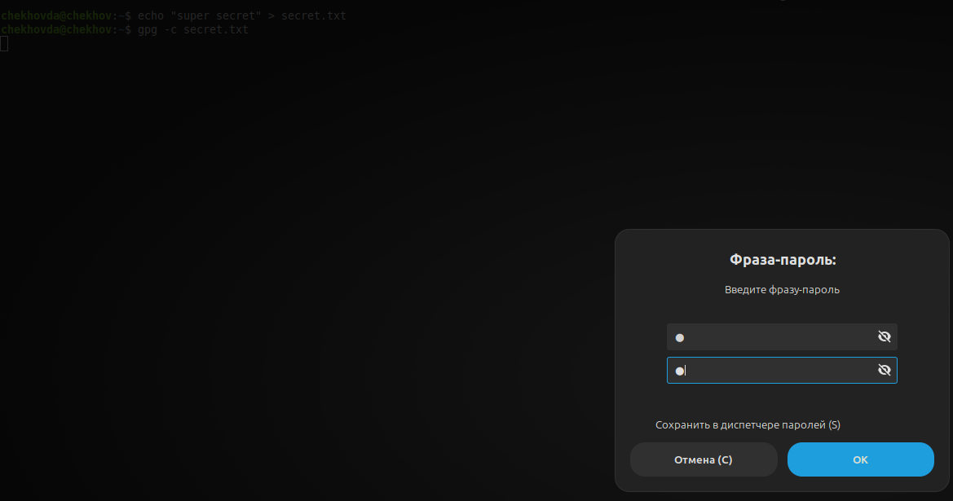

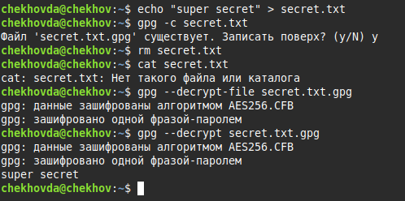

2.

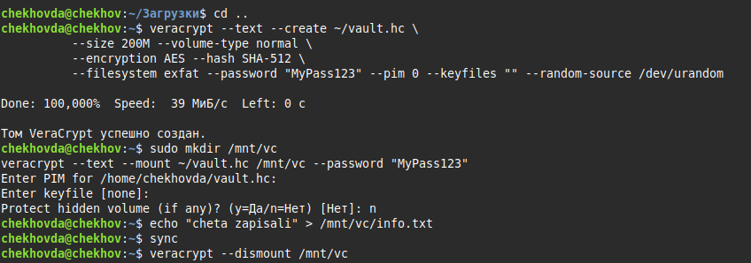

{6909C274-F5EF-49C5-BDD3-405AFDD6006F}

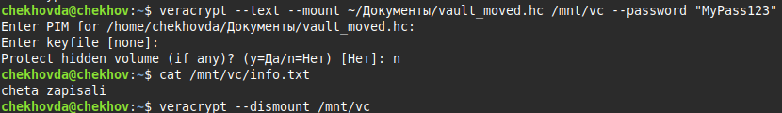

3.

{DBAEC188-3DBF-4EC7-84EA-8089B336E35F}

